Dashboard – Reports: This section lists the current reports defined in Report Writer (RW) that involve CRM data fields. You can optionally add reports from this screen too.

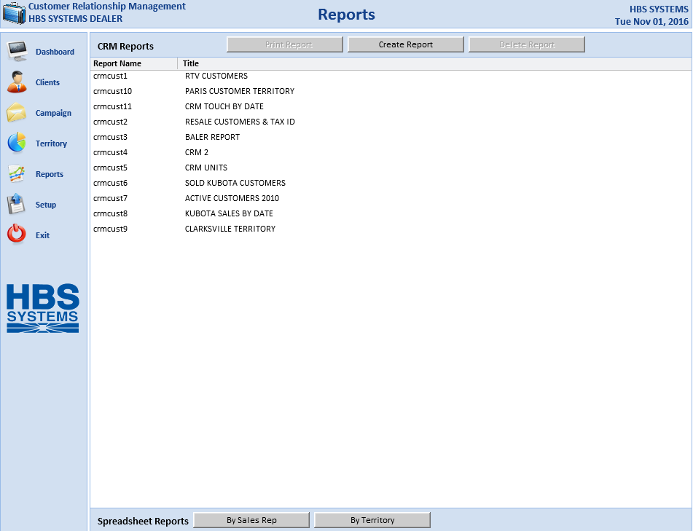

Print Report: To print an existing report, click the desired report to select it. This will activate the Print Report button. Press the button to open Print Established Report (PER).

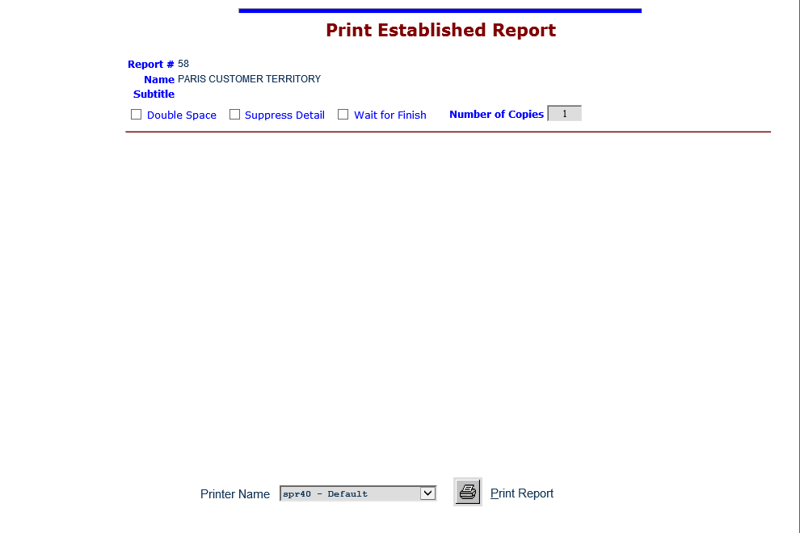

From there you can set your printing preferences and print out the report.

Create Report: To create a new report, click this button. Report Writer will open.

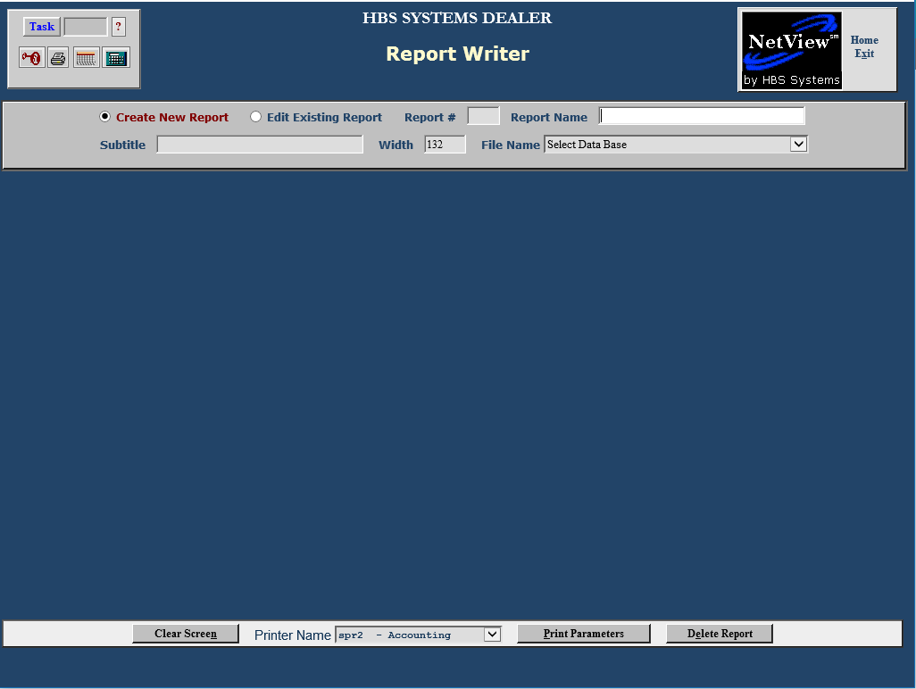

You can then create the report to your specifications. For more information, see the chapter on Report Writer (RW).

Delete Report: To delete a report, click the desired report to select it. This will activate the Delete Report button. Press the button to delete the report. You will receive a confirmation message from CRM.

Spreadsheet Reports: These buttons allow you to specialized Excel spreadsheet reports.

By Sales Rep: Click this button to access the Spreadsheet Reports organized by sales representative. The following screen will appear:

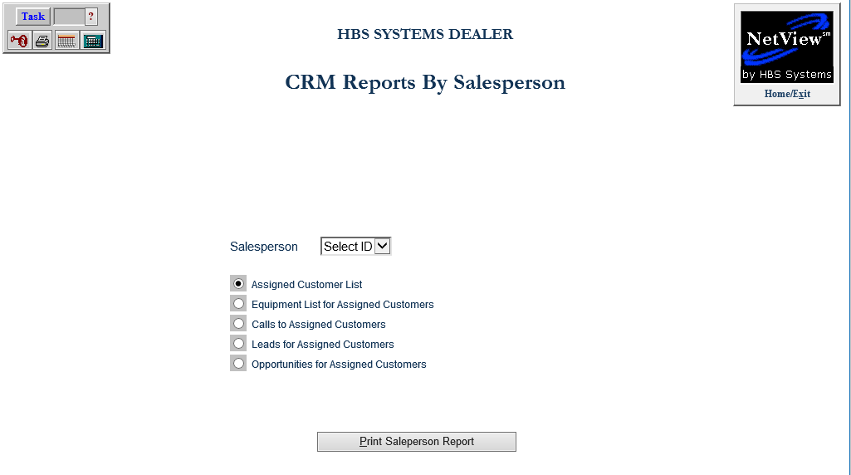

This screen offers multiple reports for export to an Excel file, as well as some options to customize them. Once you have selected a report, click Print Salesperson Report to create the Excel file.

Salesperson: You can select an individual salesperson as the subject of the report using this drop-down menu. If available, you can also select All to have the report cover ALL your salespeople.

Assigned Customer List: Select this option to create a list of the customers assigned to a salesperson. If you have selected “All” salespeople, the report will list all customers organized by salesperson.

Equipment List for Assigned Customers: Select this report to create a list of equipment owned by customers assigned to that salesperson, with the equipment organized by customer. If you have selected “All” salespeople, the report will list the equipment organized by customer and the customers organized by salesperson.

Calls to Assigned Customers: Select this report to create a list of each salesperson’s Calls to their assigned customers, organized by the customer. If you have selected “All” salespeople, the report will list the Calls organized by customer and the customers organized by salesperson. Set the report period by either typing the dates in the available fields or using the arrows to select the dates from a calendar.

Leads for Assigned Customers: Select this report to create a list of each salesperson’s Leads for their assigned customers, organized by the customer. If you have selected “All” salespeople, the report will list the Leads by customer and the customers by salesperson. Set the report period by either typing the dates in the available fields or using the arrows to select the dates from a calendar.

Opportunities for Assigned Customers: Select this report to create a list of each salesperson’s opportunities for their assigned customers, organized by the customer. If you have selected “All” salespeople, the report will list the opportunities by customer and the customers by salesperson. Set the report period by either typing the dates in the available fields or using the arrows to select the dates from a calendar.

By Territory: Click this button to create an Excel spreadsheet listing the customers according to their assigned Territory. The following screen will appear:

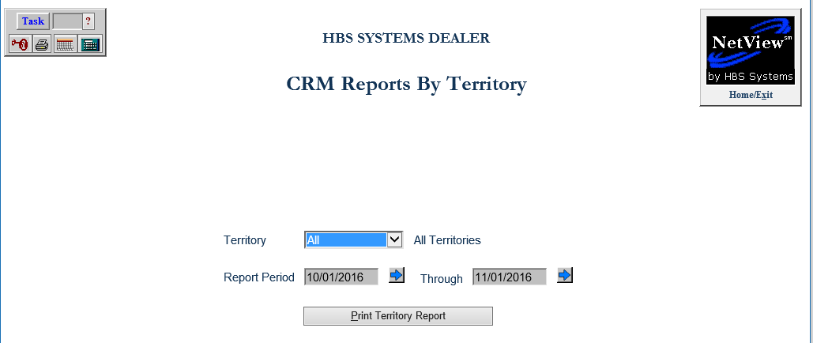

Select an individual Territory for the report from the drop-down menu. You can also select All to print the report for ALL Territories, in which case the customers will be organized by Territory on the report. Set the report period by either typing the dates in the available fields or using the arrows to select the dates from a calendar. Once you have chosen your report settings, click Print Territory Report to create the Excel file.

TIP-Territories in RW: Territories in Report Writer (RW) are defined by the CRM Category data base. You can link this file with the CRM Customer file to obtain a list of Territories for your salesperson.

- Category: holds the value of Territory, along with other identifiers not related to this report.
- Type: the name of the Territory (whatever was established in Territory assignments in SLSM).
- CRM ID: the common field for linking, both from CRM Categories and CRM Customer.

After you link the CRM ID, you can then use the CRM Customer file to log any customer information required.

